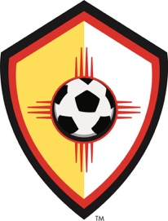

The governing body for youth soccer in New Mexico, affiliated with US Youth Soccer,
the United States Soccer Federation (USSF), and the Fédération Internationale de Football Association (FIFA)

CREDENTIALS REPORT

Tournament:
Date(s):

Number of teams in tournament:
Number of NMYSA teams checked in: Number of out-of-state teams checked in: Number of other teams checked in:
List problems / corrections you made with the NMYSA teams:
(be specific giving all the information possible)

List problems / corrections you made with the out-of-state teams or other teams:
(be specific giving all the information possible)

Submitted by: Position:

PLEASE FILE THIS REPORT WITH THE TOURNAMENT REPORT. PLEASE SEND A COPY OF THIS REPORT TO THE NMYSA STATE REGISTRAR.
Rev 09/2021

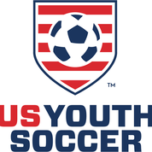
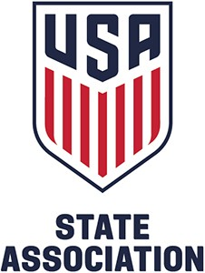
2825 Broadbent Parkway NE, Suite D • Albuquerque, NM 87107
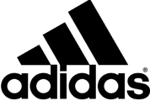
Administrative Office: (505) 830-2245 • office@nmysa.net Coaching Department: (505) 830-2246 • coach@nmysa.net fax (505) 830-2247 • http://www.nmysa.net/

